-----Original Message----
Ron Lee/PACIFIC/BAX/SIN Operation Executive Logistics / HP - Program (HP-G9) Singapore 24/04/2006 07:58 PM
To: Clarito Ablanque/PACIFIC/BAX@BAX, Rose Pang/PACIFIC/BAX@BAX
Cc: Andrew Lim/PACIFIC/BAX@BAX, ChristopherYK Lim/PACIFIC/BAX@BAX, EngKiat Kang/PACIFIC/BAX@BAX, Muhd Ridzal/PACIFIC/BAX@BAX, Steve Chan/PACIFIC/BAX@BAX
Subject: Re: Labels for Motorola Outgoing Shipments

Hi Clarito,
Some modification here as per attached. I only need these data below, ignore the 1st label format. I'll raise ASR tomorrow.........Thx.
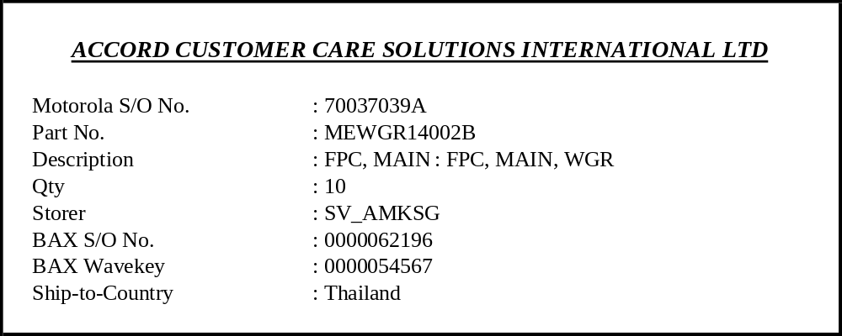

The label size is 1/10 of an A4 size paper as shown below.
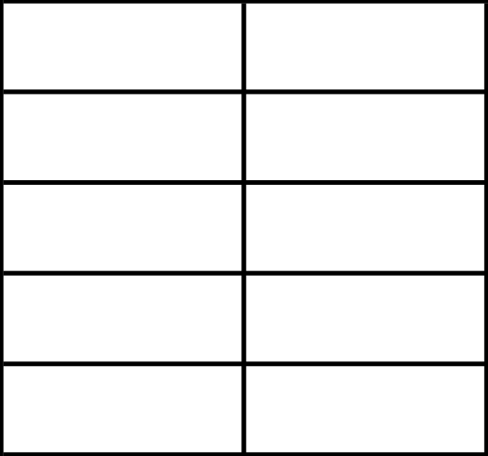

Hi Rose,
As spoken, kindly ask for quotation or assist to hunt at popular bookshop if u happen to pass by.............Thx.
___________________________
Cheers,
Ron Lee
BAX Global Pte Ltd
(Motorola Program)
Tel: (65) 6267 5078
Fax: (65) 6266 7005
E-mail: ron.lee@baxglobal.com

-----Original Message----
Clarito Ablanque/PACIFIC/BAX/SIN IT Senior Information Analyst Logistics IT Singapore 24/04/2006 04:06 PM
To: Ron Lee/PACIFIC/BAX@BAX
Cc: Andrew Lim/PACIFIC/BAX@BAX, ChristopherYK Lim/PACIFIC/BAX@BAX, Muhd Ridzal/PACIFIC/BAX@BAX, Ron Lee/PACIFIC/BAX@BAX, Rose Pang/PACIFIC/BAX@BAX, Steve Chan/PACIFIC/BAX@BAX, EngKiat Kang/PACIFIC/BAX@BAX
Subject: Re: Labels for Motorola Outgoing Shipments

Ron Hi,

I thought we will do trial first.

Anyway, as SOP please raise ASR and we will prioritize it accordingly.

In addition, kindly give me the size of the paper for priter settings. Thanks

Rgds,
Clarito

-----Original Message----
Ron Lee/PACIFIC/BAX/SIN Operation Executive Logistics / HP – Program (HP-G9) Singapore 24/04/2006 03:58 PM
To: Ron Lee/PACIFIC/BAX@BAX
Cc: Andrew Lim/PACIFIC/BAX@BAX, ChristopherYK Lim/PACIFIC/BAX@BAX, Clarito Ablanque/PACIFIC/BAX@BAX, Muhd Ridzal/PACIFIC/BAX@BAX, Steve Chan/PACIFIC/BAX@BAX, Rose Pang/PACIFIC/BAX@BAX
Subject: Re: Labels for Motorola Outgoing Shipments

Hi Clarito,
I need this thing urgently....... Ignore the "Motorola Invoice No.". As for Part nos. and qty, pls make the font bigger & darker. Thx.

Hi Rose,
Have u purchase the label?

___________________________
Cheers,
Ron Lee
BAX Global Pte Ltd
(Motorola Program)
Tel: (65) 6267 5078
Fax: (65) 6266 7005
E-mail: ron.lee@baxglobal.com

-----Original Message----
Ron Lee/PACIFIC/BAX/SIN Operation Executive Logistics / HP – Program (HP-G9) Singapore 15/04/2006 10:08
To: Clarito Ablanque/PACIFIC/BAX
Cc: ChristopherYK Lim/PACIFIC/BAX@BAX, Andrew Lim/PACIFIC/BAX@BAX, Muhd Ridzal/PACIFIC/BAX@BAX, Steve Chan/PACIFIC/BAX@BAX
Subject: Labels for Motorola Outgoing Shipments

Hi Clarito,
As spoken, below is the format of the label. A quater size of an A4 size paper per label (4 labels per A4 size paper).
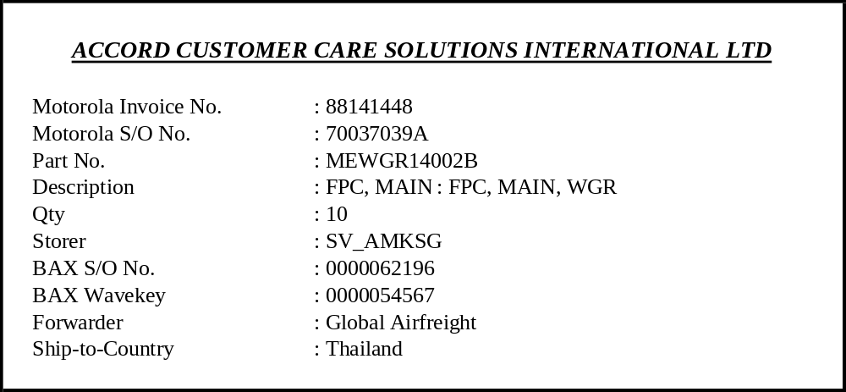
Cheers,
Ron Lee
BAX Global Pte Ltd
(HP Program)
Tel: (65) 6374 7239
Fax: (65) 6270 5560
E-mail: ron.lee@baxglobal.com

